**Arifureta Season 2: Release Date and other details!** 

**Arifureta: From Commonplace to World's Strongest**, a *Japanese fantasy anime* grounded on the manga light novel series "*Arifureta: From Commonplace to World's Strongest Zero*" written by Ataru Kamichi, Ryo Shirakome, illustrated by Takayaki and published by Overlap. The series was the 27th best-selling light novel series in the first half of 2017 with a promising storyline.

**Arifureta Season 2: Release Date**

Initially, an *anime television series* adaption of the *light novel series* was announced on December 3, 2017. Earlier it was planned to **release** in April 2018 but its premiere was pushed back to January 15, 2018, due to inevitable circumstances. So then after the production completion **Arifureta Season** 1 streamed from July 8, 2019, to October 7, 2019, on the following platforms: AT-X, Tokyo MX, SUN, and BS11. It comprised 13 episodes. After the 13th episode streaming, the creators of the anime announced the renewal of the series for two OVAs and another **season** i.e., **Arifureta Season 2**. Then two OVA (Original Video Animations) was released on December 25, 2019, and February 26, 2020, simultaneously. Until there's no official announcement of the **release date** of **Arifureta Season 2**. So, we can expect the **Arifureta Season 2 release** at any time in 2021 as soon as the cast members finish the shoot and production of the anime.

**Arifureta Season 2: Probable Cast and Plot**

Although there's no official announcement on the same, we can expect the protagonists of the *anime series* to repeat their roles. But there may be the addition of a few more characters and actors but nothing has been unveiled yet. So, let's recap few characters who appeared in Season 1 and the two OVA's and are therefore likely to appear in **Arifureta Season 2** either as alive or in the flashbacks if they died in **Season** 1.

|  |  |  |  |
| --- | --- | --- | --- |
| Character | Voice actor Japanese | Voice actor English | Job Class |
| **Hajime Nagumo** | Toshinari Fukamachi | Matt Shipman | Synergist |
| Yue | Yuki Kuwahara | Tia Ballard | Divine Priestess |
| Shea Haulia | Minami Takahashi | Amanda Lee | Diviner |
| Tio Klarus | Yoko Hikasa | Morgan Garrett | Guardian |
| Kaori Shirasaki | Saori Onishi | Skyler McIntosh | Healer |
| Shizuku Yaegashi | Yumiri Hanamori | Kate Bristol | Swordmaster |
| Aiko Hatayama | Ai Kakuma | Emily Fajardo | Farmer |
| Koki Amanogawa | Tetsuya Kakihara | Ricco Fajardo | - |
| Ryutaro Sagami | Ryuichi Kijima | - | Monk |
| Daisuke Hiyama | Minoru Shiraishi | Orion Pitts | - |
| Myu | Yui Ogura | - | - |

**Hajime Nagumo**- He's a high-school student who learns very fewer transmutation skills when he's transported to another world along with his friends and batchmates. He uses his skills there to save his classmates but later on, he's betrayed by one of them and thus he's thrown into the *abyss of the dungeon.* Anyhow, he survives there using a mineral with healing properties after losing an arm to a monster. That mineral provides him the ability to survive while *feeding on the bodies of monsters* whom he defeats, he also gains the abilities of those monsters and thus he grows to be very powerful. He rescues Yue there and conquers that dungeon. He then knows the secret about the dungeon creation and its treasure. Then he decides to conquer all the seven dungeons so that he can acquire all the hidden magic in them and can return to his homeworld. While he was captured in the dungeon, he trains himself and becomes a gunsmith, who's able to craft very powerful weapons. Over time, he goes on becoming more ruthless and powerful.

**Yue**- She's a *vampire princess* who's betrayed and imprisoned by her uncle in the dungeon until Hajime saves her. She has immense magic abilities and healing power which prevents her from aging and heals her wound soon. She was imprisoned there in the dungeon for around 300 years. Later on, it's unveiled that her uncle betrayed her to save her from being a vessel to God **Ehit** because she has so much magical power. She falls in love with Hajime but doesn't get jealous of the other girls approaching Hajime because she declares herself as the wife of Hajime.

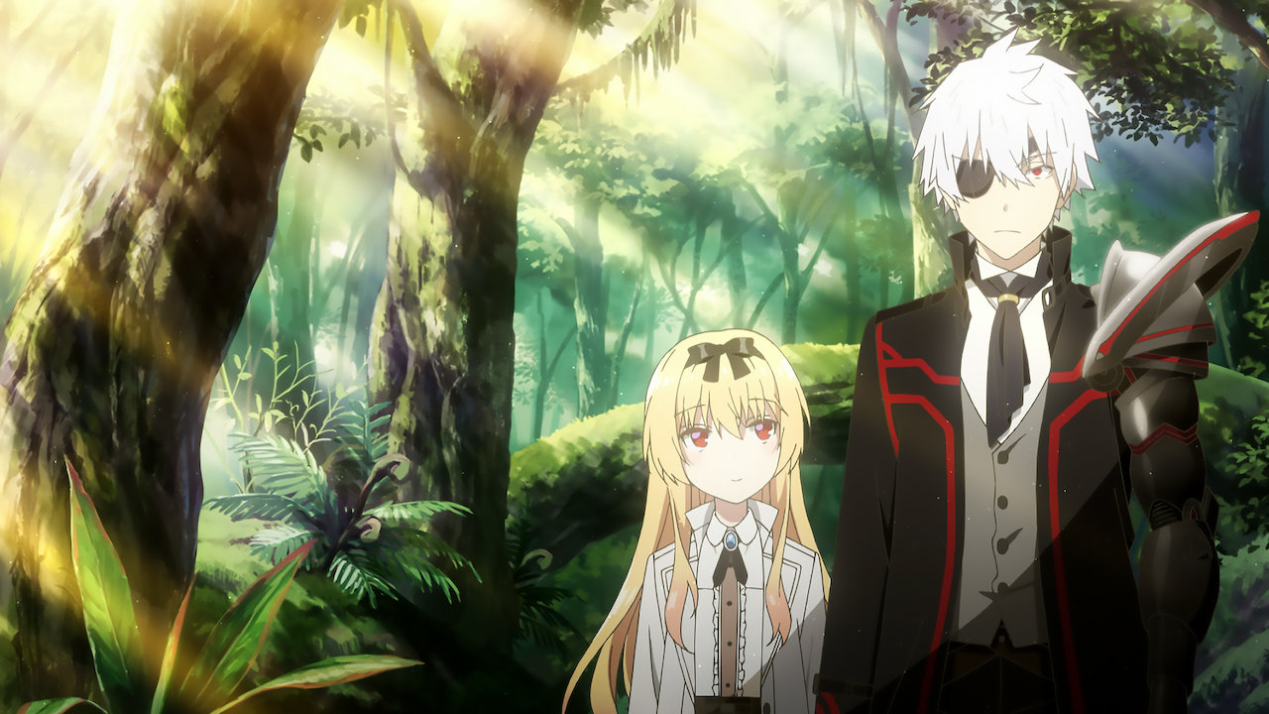Shea Haulia- She's a rabbit-girl who can see in the future which led her to leave her village along with her clan. She's saved by Hajime and thus she falls in love with him which annoys Hajime sometimes. Although she's a love rival to Yue, she has a sister kind of bonding with her.

Tio Klarus- She's a pervert who's treated harshly by Hajime after the latter defeats him but later on Hajime saves her from Shimizu's mind control ability and thus she starts serving him and keeps on calling him "master". She hails from the half-dragon Klarus tribe. She's 563 years old with the power of another level.

Kaori Shirasaki- She's Hajime's classmate who used to love him and was the only one who didn't believe in Hajime's death after he fell into the dungeon. After she confesses her love to Hajime, she joins him on his journey. She's always seen to be competing with Yue and other batchmates for getting the love of Hajime.

Shizuku Yaegashi- She's a good friend of Koki and Kaori. She's well-trained kendo practicing girl who's very sharp-minded with unique capabilities to not follow anyone blindly. Later in the series, she's gifted a black Kissaki Moroha Zukuri Shirasaya Katana made of the hardest mineral of Azanthium by **Hajime** which's one of his masterpieces. Then she's able to use her swordsmanship capabilities to their fullest.

Aiko Hatayama

She's a teacher who's also transported to the other world along with her students. Later on, she fell in love with Hajime after he saves her from poisoning, by giving her antidote mouth-to-mouth. She exposes Ehits' evil.

Koki Amanogawa

He's a childhood friend of Kaori who becomes jealous when she confesses her love to Hajime and then he starts protesting and arguing that he and Kaori should always be together because they're childhood friends. He thinks ill of Hajime because of the latter's changed behavior and thus he thinks that Hajime forces everyone to help him.

Ryutaro Sagami- He's Koki's best friend and batchmate of Hajime. He has superhuman strength and he fights with bare hands.

Daisuke Hiyama- He's Hajimes' classmate, who cheated on him and led Hajime to fall into the abyss in the dungeon. He felt jealous of Hajime because Kaori uses to like Hajime. Later on, he's killed and eaten by the monsters when he's thrown in front of them by Hajime.

My- She's a young mermaid girl who was saved by Hajime in Fuhren when she was kidnapped and was about to be sold as a slave. She initially used to call Hajime "Onii-chan" (Big brother), but later starts calling him "Papa" (Father). Although Hajime becomes her father unwillingly, still he becomes overprotective of her, if someone tries to harm her, showing his parental affection in front of his friends.

Thus, **Arifureta Season 2** is likely to revolve around the *adventurous journey of Hajime* with his friends and batchmates to search for all the *seven dungeons* so that he can get all the magic from them and they can go back to their home place.

**Arifureta Season 2: Trailer**

**Arifureta Season 2 trailer** has not been released by the creators as of yet so till that time you can enjoy the **trailer** of Season 1😊

https://www.youtube.com/watch?v=vyKVipIsdAI